JDE Date Notes

Setup

https://www.facebook.com/reel/1599793711731314

On gibhub.com create a new repository:

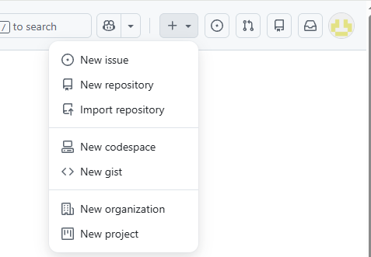

Call it jdeDate. I made public

Quick setup — if you’ve done this kind of thing before
https://github.com/NeilS42/jdeDate.git

…or create a new repository on the command line
echo "# jdeDate" >> README.md
git init
git add README.md
git commit -m "first commit"
git branch -M main
git remote add origin https://github.com/NeilS42/jdeDate.git
git push -u origin main

…or push an existing repository from the command line
git remote add origin https://github.com/NeilS42/jdeDate.git
git branch -M main
git push -u origin main

From your code folder:
D:\Code\jdeDate>git init

Code away then:

D:\Code\jdeDate>git add . (stage all files)

git commit -m "first commit"
git branch -M main
git remote add origin https://github.com/NeilS42/jdeDate.git
git push -u origin main

Development

I like to create a single page web application which will handle date conversions between JDE Julian and Gregorian formats. We already have all the functionality I need built into another, much larger, app which is location under D:\Code\JDEBoost. I’d like my new app to take all the date functionality found in template D:\Code\JDEBoost\templates\convertDate.tmpl, including the Date Format selector but we don’t need any of the functionality the app provides i.e. we don’t need:
- Any user validation
- It to run in a frame
- User interaction logging
- The need for a config DB
- The side bar with links to other pages
- A Home or About link

For the moment it can run on http, port 5010.

I will leave the styling up to you. The current app relies heavily on the styles under C:\Code\JDEBoost\soft-ui-dashboard-main but your free to create your own as long as it has a modern look and feel.

The application should be called “JDE Date”

Let me know if you have any questions.

